# PCLONE 2 MODS

The Sixty Four Pixels PCLONE2 is a recreation of the Boss PC-2 / Amdek PCK100 percussion synthesizer. As built, the kit already includes a couple of mods from the original

* VCO wave switch
* “Attack sound” on/off

However, the kit also includes three unassigned jack sockets that can be used for your own mods. This note gives some ideas to help you get started. These are mods that I found myself from educated guesswork, trial and error. There might be better ones waiting to be found… do let me know if you find any good ones!

## PITCH CV INPUT

This is a very simple mod where we apply the CV directly to the point where the LFO modulates the VCO pitch. We use a resistor (I used 100k) so the CV is mixed with the signal from the LFO and voltage from the pitch control/sweep circuit. This is NOT a tuned CV (no 1V/octave or anything!) and you may find that you need to use CV’s within a narrow part of the full voltage range for the pitch to be affected usefully. However, for just a resistor and a bit of wire, this is a nice mod.

Solder a 100k resistor to the top pin of an unused CV socket. Solder a wire to the other end of the resistor

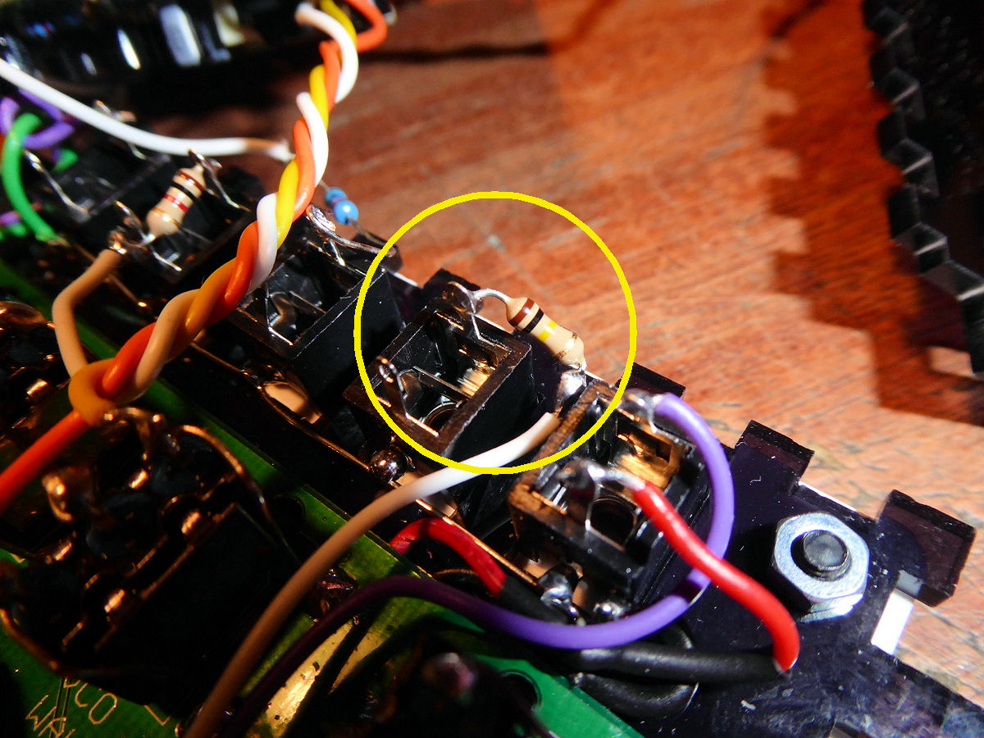

Connect the other end of the wire to the left tab of the DEPTH pot. Done!

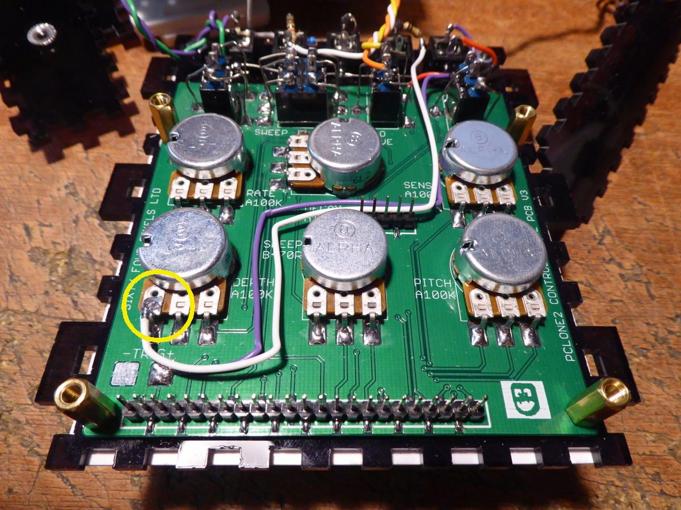

## DURATION CV INPUT

This is another simple mod that allows CV control of the sound duration. This messes with the decay/pitch envelope with some interesting results. You need to turn the DECAY knob up to allow the mod to work. Based on the input CV, the sound can be choked off or play a solid burst of sound. When the CV input is disconnected the envelope functions normally

Solder a 15k resistor to the top pin of an unused CV socket. Solder a wire to the other end of the resistor

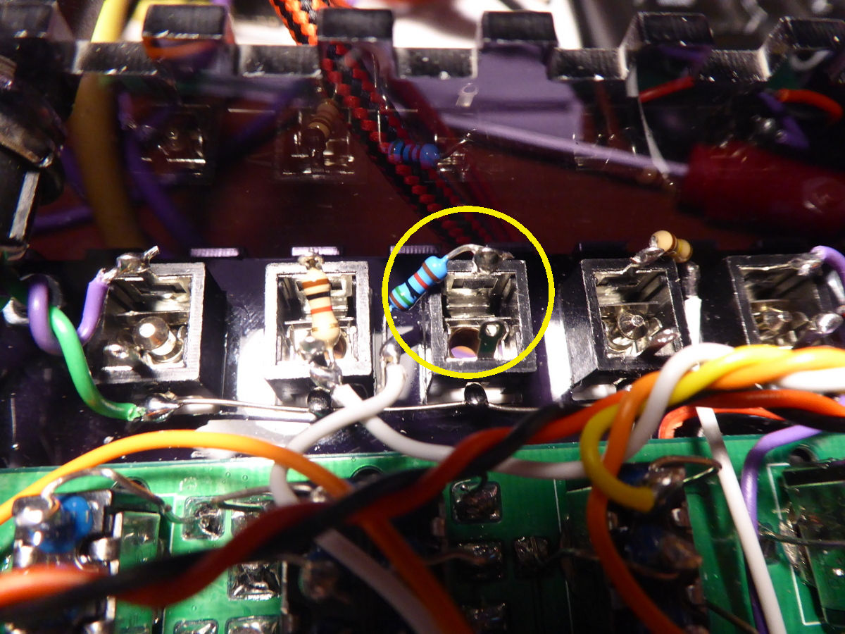

Connect the other end of the wire to the pad below IC3

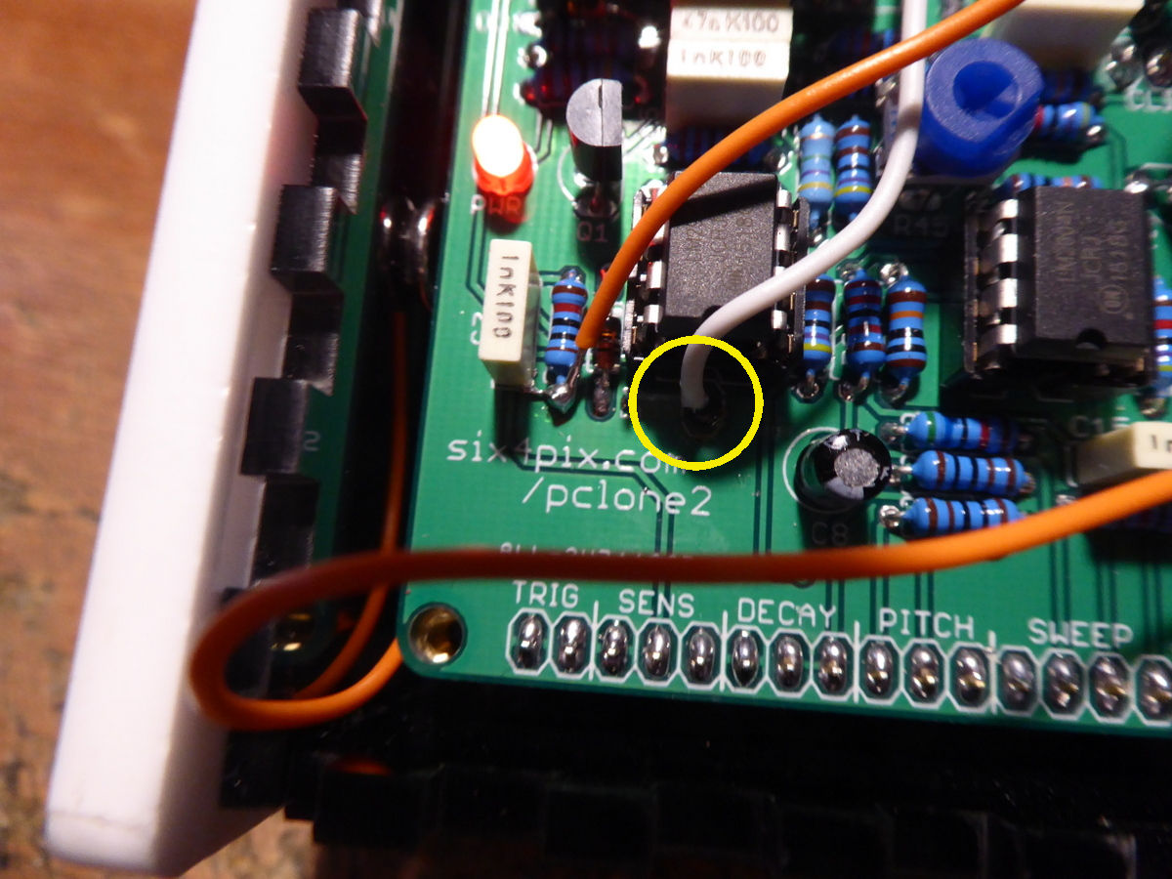

## VCO WAVE MIDI CV

This mod mixes the triangle and square VCO wave forms together when a CV is applied to the input socket. Since the square wave is significantly louder and more abrasive than the triangle, this can be used to give a rhythmic bit of edge to the sound – almost, but not quite, like a burst of white noise.

This is a slightly more complex mod, requiring use of the prototyping area on the PCLONE2 PCB. The arrangement we will be building is this

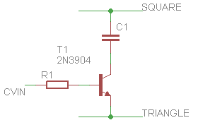

R1 is a 1k resistor and C1 is a 100nF ceramic capacitor

Lay these out on the prototyping are as shown below (avoid the top row as it is a +9V power rail)

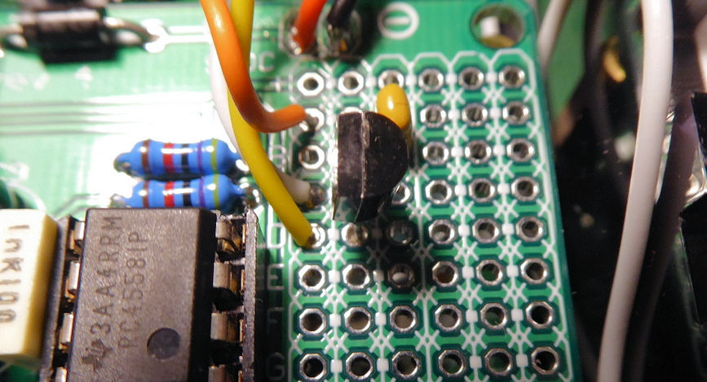

The capacitor is soldered from points A3 to B3. The transistor is soldered B2, C2, D2. Make sure the “D” shape body of the transistor is the right way around.

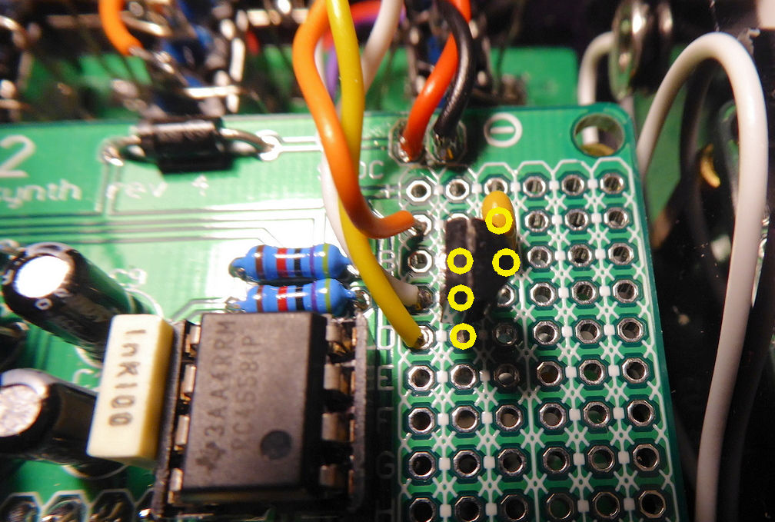

Connecting a 1k resistor to a CV socket and attach a wire to the other side of the resistor. Solder the other end of the wire to point C1 on the prototyping area.

Solder wires to the outer two pins of the VCO wave switch. The upper wire (yellow in the photo) is then soldered to pad D1 on the prototyping area and the lower wire (orange) goes to pad A1

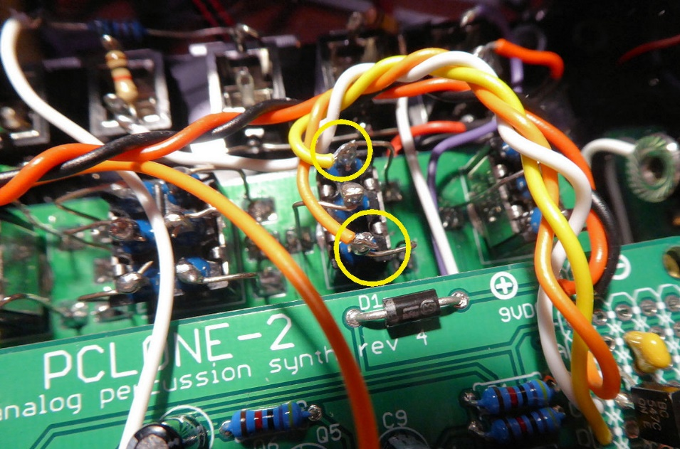

## BODY CONTACTS

You can change the sound of the synth in a lot of odd and interesting ways by touching certain parts of the circuit with your fingers. This is much more convenient if those contact points are broken out to the outside of the enclosure, and a good way to do this is via the four bolts which hold the side panel on.

**Be warned, however, that this does expose some parts of the circuit to potential damage from external voltages, short circuits and electrostatic discharge (you have been warned… although mine has survived well so far!).**

So here are some interesting contact points I found:

The first two points are around C15, the capacitor which defines the base frequency of the VCO. Since this is a low capacitance (1nF) just holding the contacts has a noticeable effect on the base pitch (the one that sounds before a sweep begins). These contacts also have interesting effects when bridging then to other contact points with your fingers (do not directly join contact points together with a conductor!)

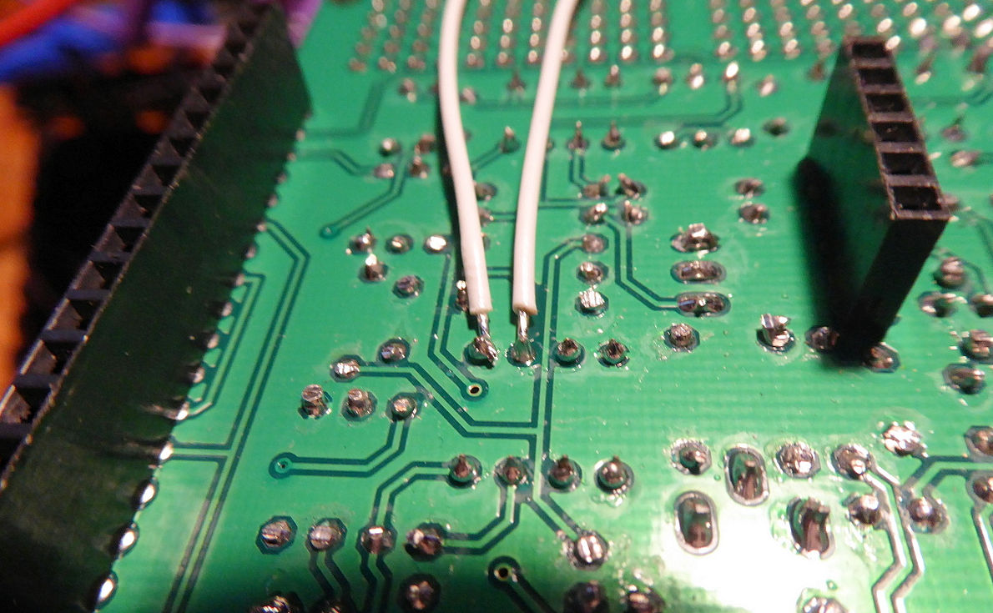

Another couple of interesting contact points are around the modulation depth (allowing bursts of LFO modulation when touched) and on the trigger circuit (which can open the envelope or cause some weird glitchy retriggering when touched in combination with other contacts)

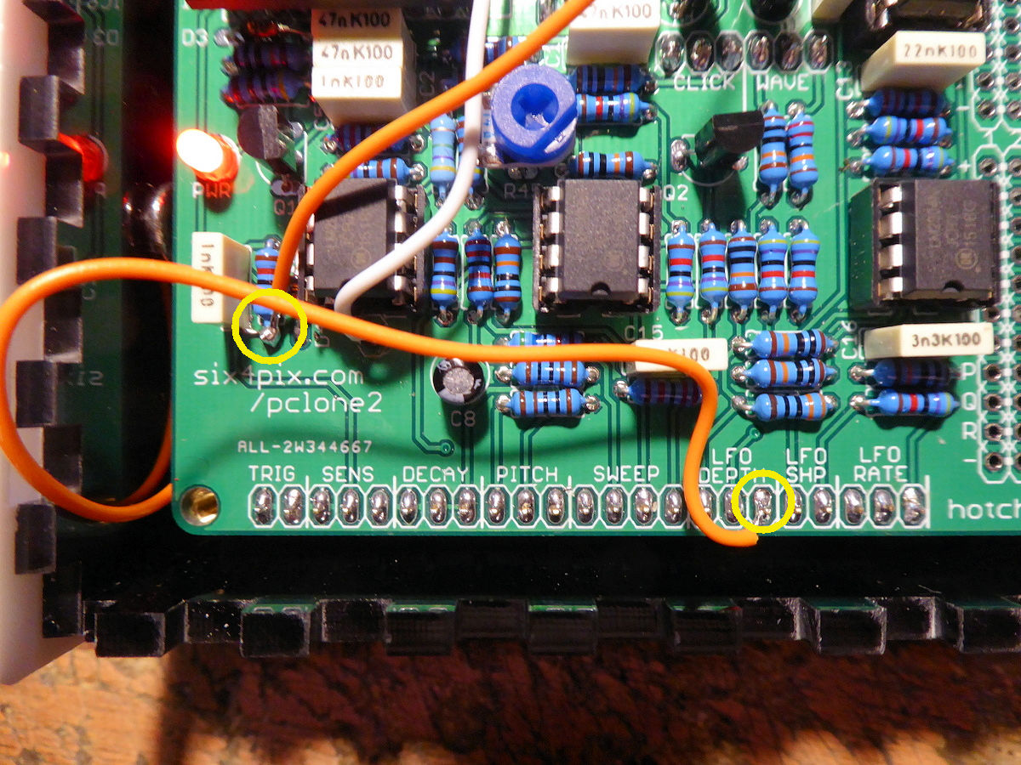

Strip the ends of the wires and remove the flange nuts from the side panels. Push the stripped end of the wire into the hole and push the flange nut back so it holds the wire in place. Replace the side panels and screw in the retaining bolts. These four bolts are now connected to the contact points…

